**Mockito Exercises**

**Exercise 1:** Mocking and Stubbing

OUTPUT:

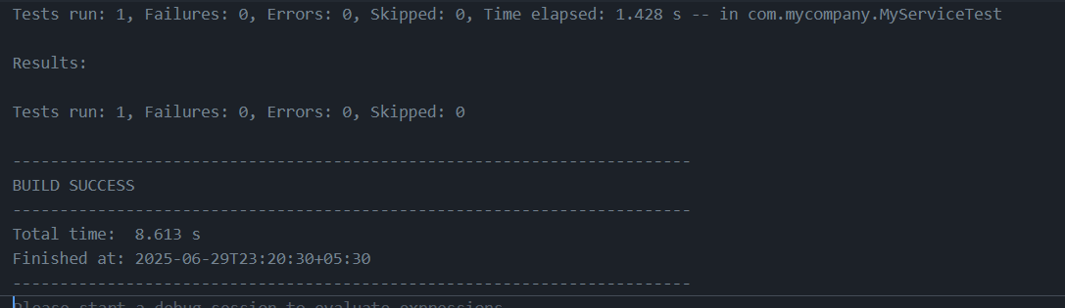

**Exercise 2:** Verifying Interactions

OUTPUT:

